ShopEZ Angular Frontend

1. Project Title
ShopEZ – Angular E-Commerce Frontend Application

2. Project Overview
ShopEZ is a modern e-commerce frontend application built using Angular. It provides a complete shopping experience including product browsing, search, cart management, authentication, checkout flow, and admin dashboard. The application communicates with a RESTful backend API (ASP.NET Core) using JWT authentication.

3. Objectives
• Build a scalable Angular frontend
• Implement authentication and authorization
• Enable product browsing and filtering
• Provide cart and checkout functionality
• Integrate with backend REST APIs
• Follow modular and reusable architecture

4. Tech Stack
• Frontend: Angular 17+
• Language: TypeScript
• Styling: CSS / Bootstrap
• State Management: RxJS Services
• API Communication: HttpClient
• Authentication: JWT
• Backend: ASP.NET Core Web API

5. System Architecture
Angular Components
↓
Services (Business Logic)
↓
HTTP Client
↓
Interceptor (JWT Token)
↓
Backend API (ASP.NET Core)
↓
SQL Server Database

6. Application Flow
User Login/Register
↓
Browse Products
↓
Search / Filter Products
↓
View Product Details
↓
Add to Cart
↓
Checkout
↓
Order Confirmation
↓
Order History

7. Project Structure
src/app
├── components/
├── pages/
├── services/
├── guards/
├── interceptors/
├── models/
├── admin/
└── app.routes.ts

8. Features
User Features:
• Login / Register
• Product Search
• Add to Cart
• Checkout Flow
• Order History
Admin Features:
• Product Management
• Order Management
Technical Features:
• JWT Authentication
• Route Guards
• HTTP Interceptor
• Reactive Services (RxJS)

9. Screenshots
Home Page - 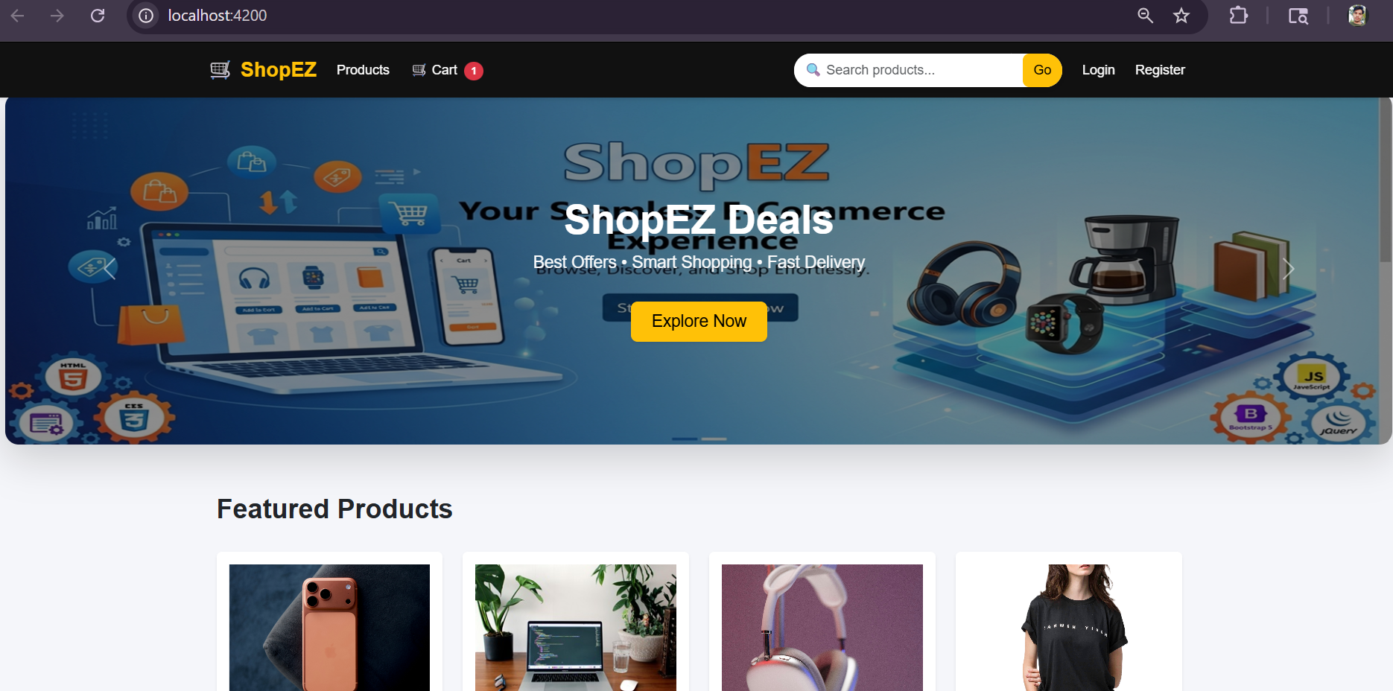
Product Listing Page - 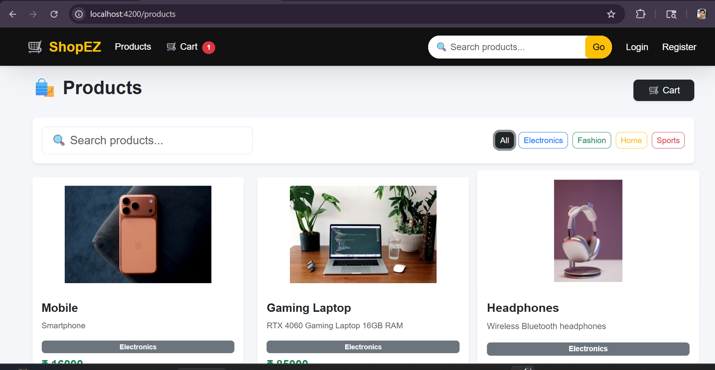
Search Feature - 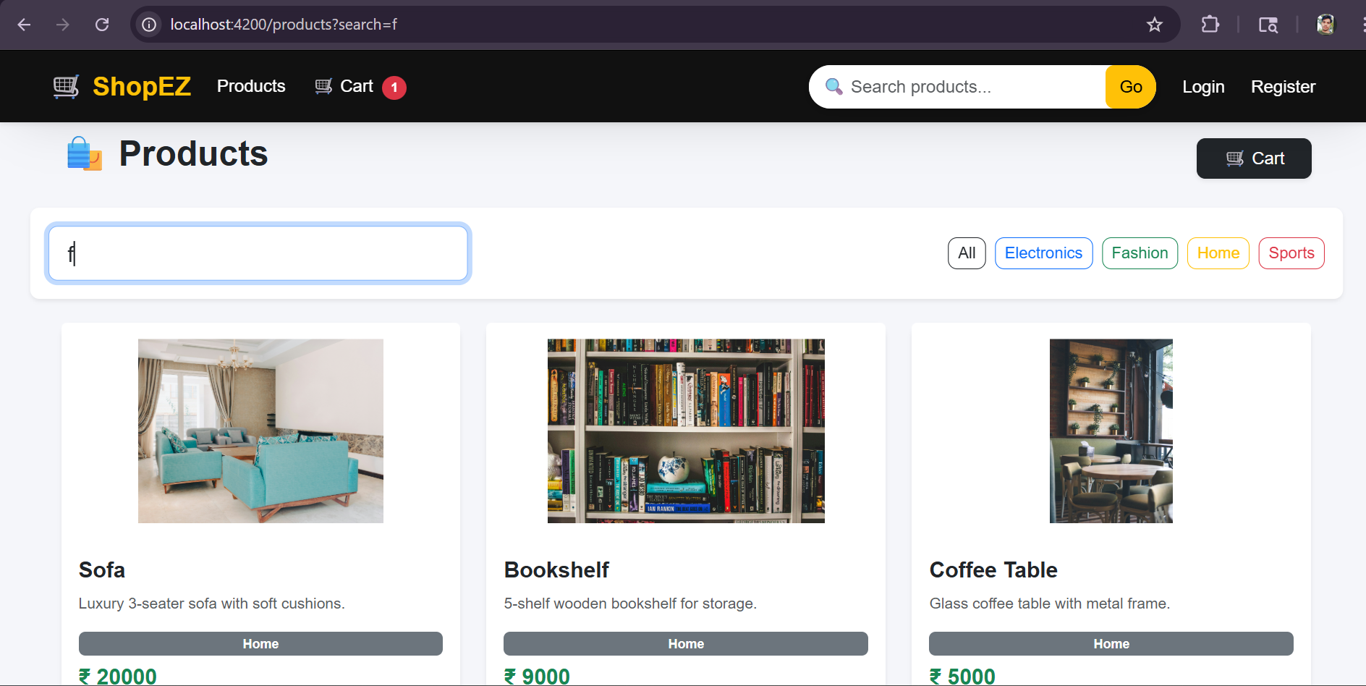
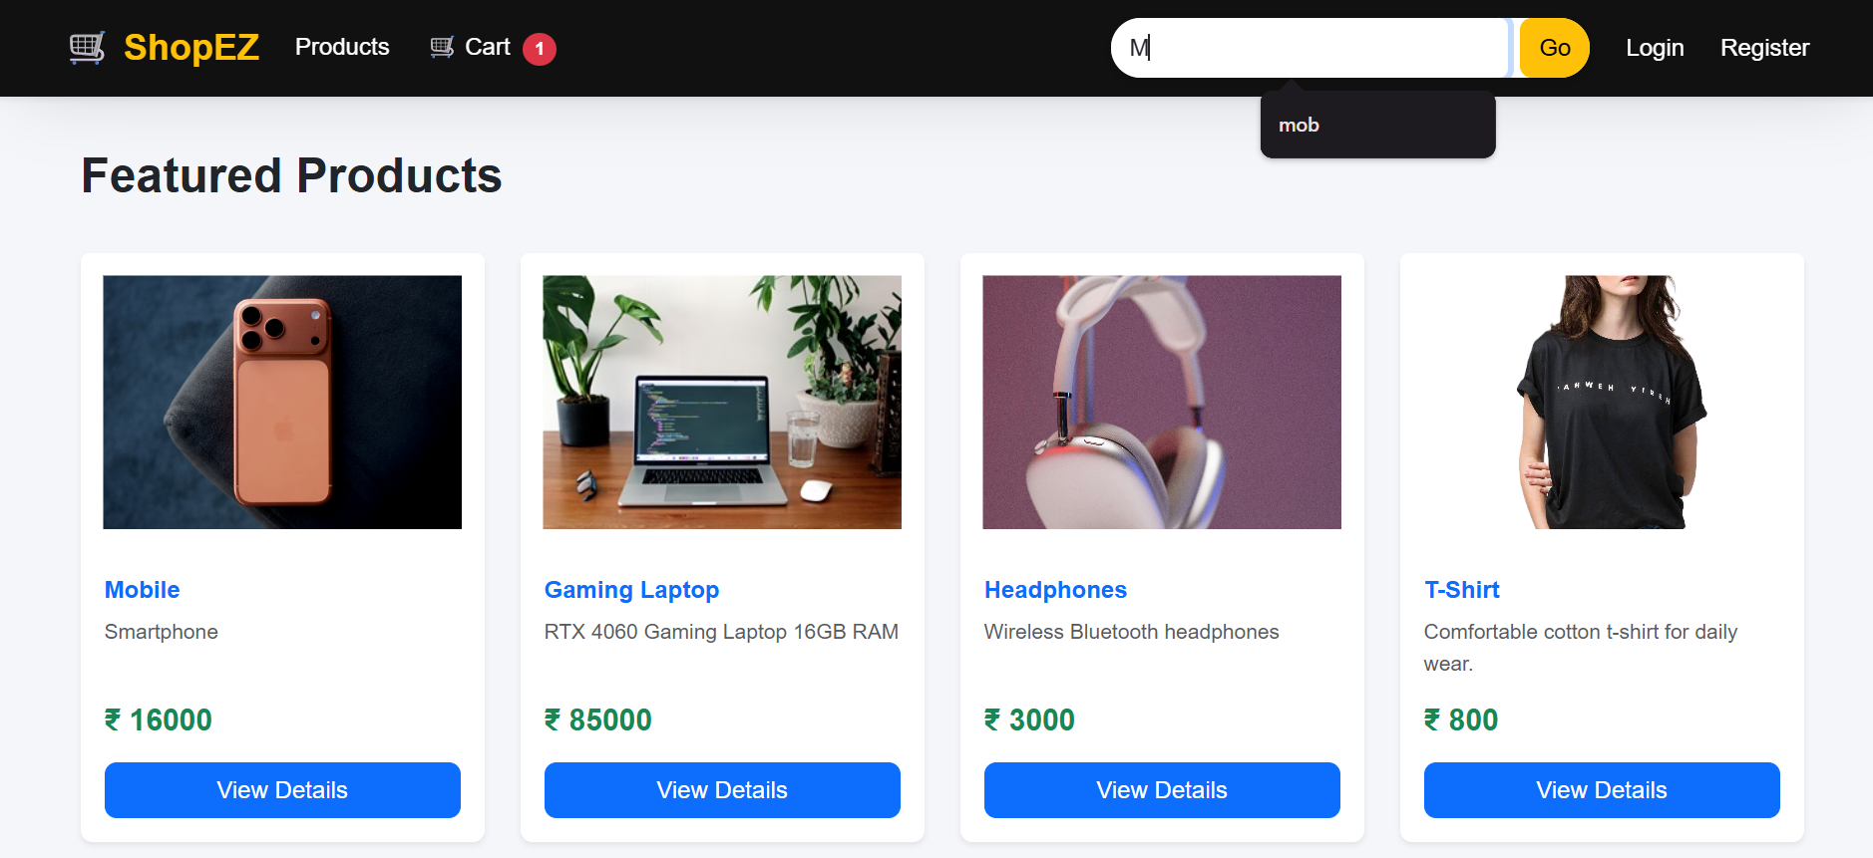
Cart Page - 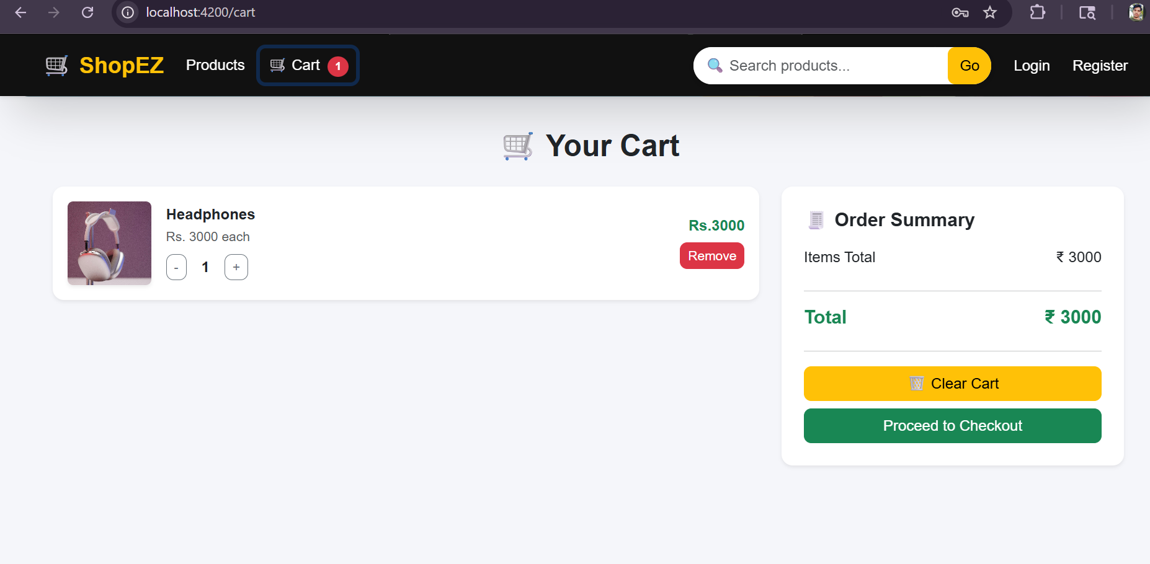
Checkout Page - 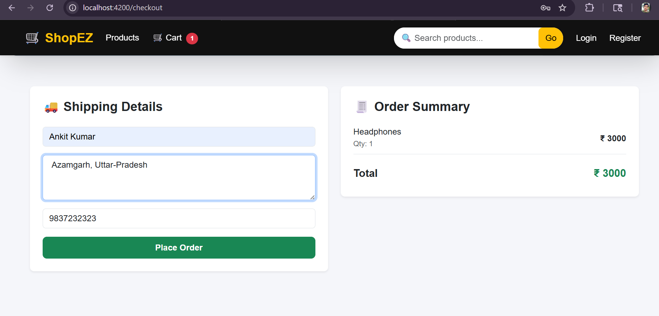Login Page - 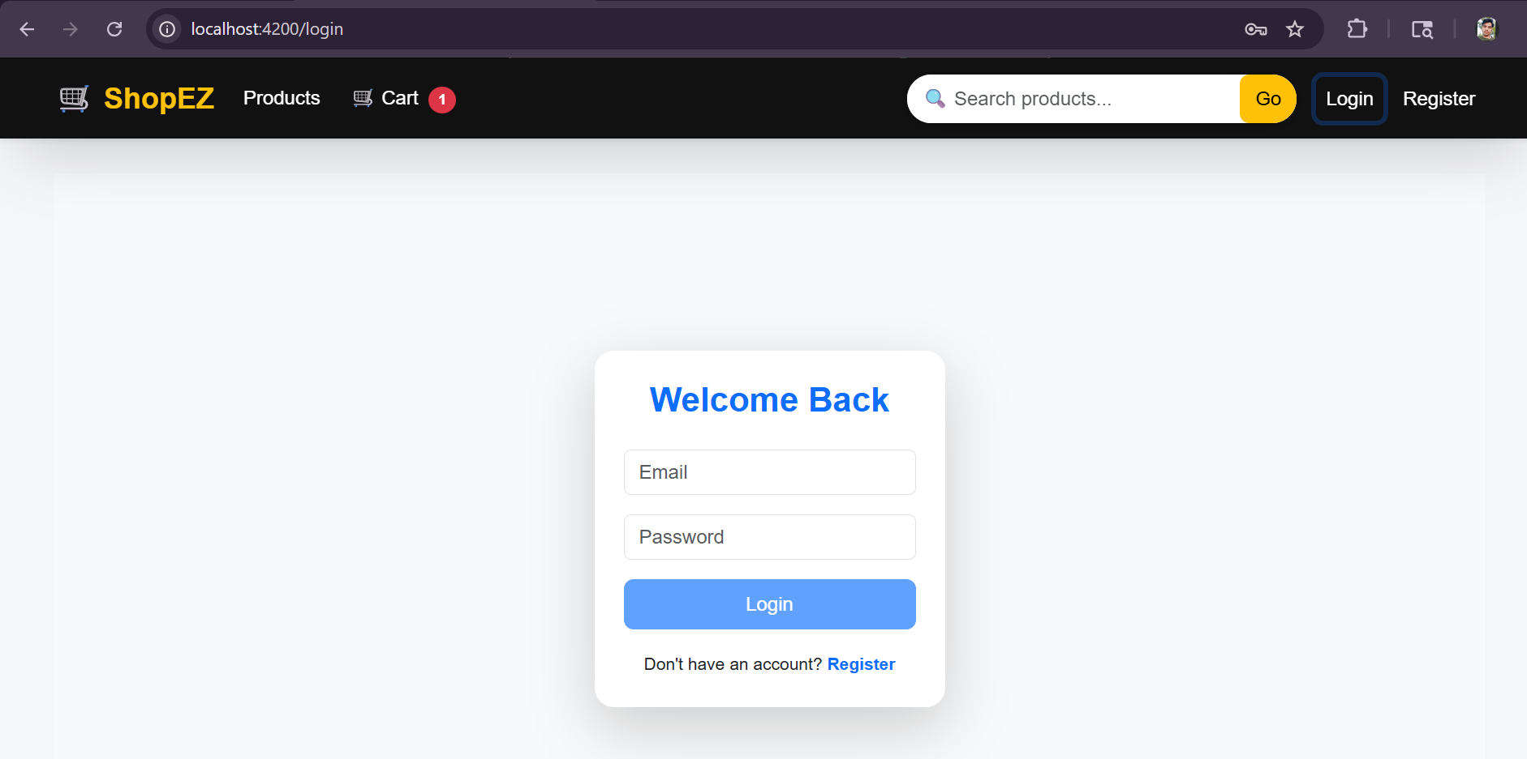

10. Authentication Flow
User Login
↓
AuthService API Call
↓
JWT Token Generated
↓
Stored in LocalStorage
↓
Interceptor Adds Token
↓
Guard Protects Routes

11. Cart System Flow
Product → Add to Cart
↓
CartService (RxJS)
↓
Cart Updates UI
↓
Checkout Process

12. Search System
User Input
↓
ProductService API Call
↓
Filter Products
↓
Display Suggestions
↓
Navigate to Product Details

13. Testing
• Unit Testing using Jasmine/Vitest
• Component Testing
• Service Testing
• Mocking API responses

14. How to Run Project
npm install
ng serve
http://localhost:4200

15. Future Improvements
• Payment Gateway Integration (Razorpay/Stripe)
• Wishlist Feature
• Product Reviews
• NgRx State Management
• Lazy Loading Modules

16. Author
Ankit Kumar - Full Stack Developer (Angular + .NET )

